2021

Maintenance Guide

At every exit
Verify the condition of torsion bars
Verify the tire condition and pressure according to tire recommendations
Verify the condition of the safety chains
Verify wheel bolt clamping
Verify the emergency brake operation
Verify battery level and charge as required
Verify the bathroom GFI outlet if it’s working
Verify sewer outlet for leaks and /or possible damaged on road
Verify the general condition of the RV

Weekly
Outside cleaning of the RV
Check the clamping of the «Ptrap» (kitchen sink and bathroom)

Monthly
Verify roof sealants
Verify the sealants on the 4 corners of the RV
Verify windows and doors sealants
Verify the sealants of the attachments to the exterior walls
Verification of the clean water pipes for leaks
General verification of the slide out
Lubricate the mechanism of the slide out
Verify electrolyte level in battery (add as needed)
Verify smoke, propane and CO2 detectors for proper operation
Clean the fan and filter in the stove hood
Remove and clean air conditioner filter
Clean air conditioning vents
Verify and clean furnace exterior chimney as required
Verify and clean ventilation door and refrigerator access if necessary
Lubrication of friction points (zerts) of torsion bars

Bi-annuel
Can be done by the client
Rubber roof cleaning and treatment
Cleaning of RV and application of polymer wax
Complete cleaning of canvases followed by sealing treatment (tent trailers and hybrids only)
Remove floor dampers and clean vents
Change the batteries of the different detectors and test them
Verify fire extinguisher level and condition
Lubricate the steps
Lubricate doors and hinges as required (doors, trunk doors, etc.)
Clean roof vents and lubricate mechanism and hinges
Lubricate window mechanism (if required)
Lubricate door lock mechanism (if required)

Can be done by the client or the dealer
Verify the condition of the propane ducts under the vehicle for road damage (if accessible)
Verify the condition of accessible propane lines for possible leaks
Verify the propane hose tightness at tanks and regulator
Verify the condition of propane regulator and clean vent

Annual
Can be done by the client
Replacement of drinking water filter
Installation of a special air conditioning cover (winter season only)
Installation of a special protective cover for RV (winter season only)
Clean balck water tank
Lubricate black and grey water drain valve
Verify the condition of anode rod (Suburban water heater only)
Lubrication of toilet seal
Purify the drinking water system and tank

Can be done by the client or the dealer
Winterization of the drinking water system (fall) – see all details in the winterization section

Recommended to be performed by an accredited dealer
Maintain bearing system (grease, check ball bearings) OR every 8,000 km
Preventive maintenance of RV electrical brakes OR every 8,000 km
Verify the condition and tightening of suspension bolts
Verify the condition of suspension components
Propane leak system check (drop pressure test)
Clean stove burners and verify the condition of porcelain
Verify the stove burner alignment
Verify the condition of water heater flame
Cleaning the water heater pilot
Clean refrigerator coil and burner
Clean refrigerator capacitor
Clean the tip of the refrigerator thermocouple
Verify refrigerator electrode spacing

Essential maintenance recommended by the manufacturer
Your RV requests preventive maintenance in accordance with the owner’s guide. Minor adjustments and adjustments (e.g. door adjustments, cabinet latches etc.) will be made by the dealer if they are mentioned within 30 days of the delivery date of the unit to the customer. After this period, they are part of the normal and preventive maintenance and are the responsibility of the owner.

The following is a mandatory monthly preventive maintenance checklist for your RV:

Sealant (to do, add and/or change as required)
The corners molding
Front and rear bed doors (hybrid only)
The compartment doors
The entry door
The windows
The entry door and compartment doors hinges
The signal and gauge lights
The entrance of electrical cable, city water and water tank
Ventilation duct for furnace and range hood
The water heater tank
The outsider shower
The fenderskirts
Any other openings or attachments to walls

Roofing (to do, add and / or change as needed)
Complete VR verification (moulding joint wall / roof)
Moldings, joints with front and rear walls
Air vents (vents on roof top)
The air ducts (plumbing and refrigerator)
All domes and skylights
Radio and TV antenna
The roof of the slide out
Checking the membrane itself for damage

General Lubrification
Stabilizing Jacks
Entry door and compartment doors lock
Slide out rubber
Slide out mechanism
Steps
Black and grey water outlet valve

It is important to understand that humidity in the ambient air and condensation are NOT caused by the materials or construction methods of your RV. Good ventilation (stove hood, bathroom fan, etc.) when using the RV is essential since it represents a very limited space. Its use in cold temperatures accentuates the phenomenon of condensation. Poor or non-existent maintenance of external sealants also causes problems, including water infiltration. This is why all these conditions are not applicable on the warranty of the vehicle not being due to a manufacturing or material problem.

TOUJOURS
Close tente trailers or hybrids ONLY if they are dry. Wet or wet canvas will cause mould and can cause major damage to both the canvas and the RV itself.
The awnings will have the same problem as the canvases. Always close the awning dry.

Main care points for sealants
Légende :
- Corner moldings
- Roof accessories
- Roof / /floor extension
- Doors / windows
- Compartment doors / Acces doors / Fenderskirts
- Lights
Travel Trailers
Fifthwheels
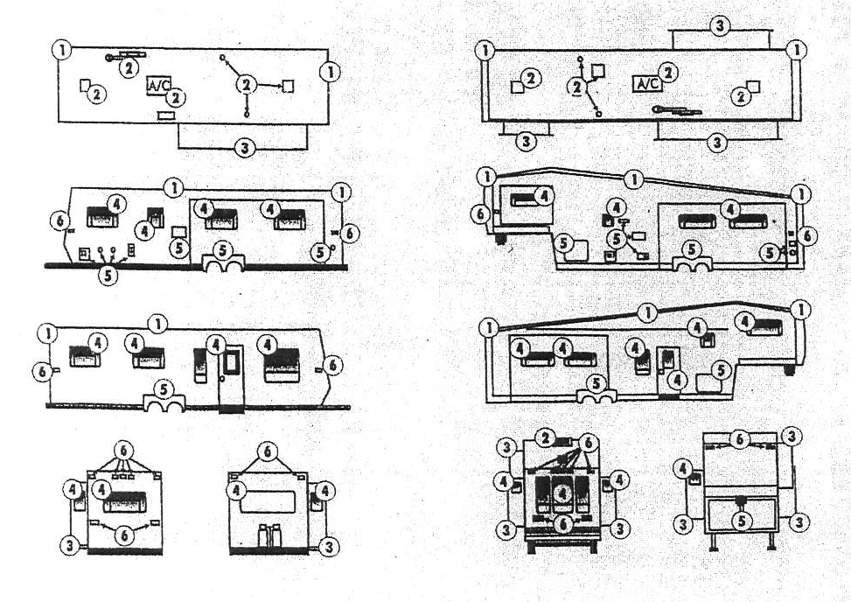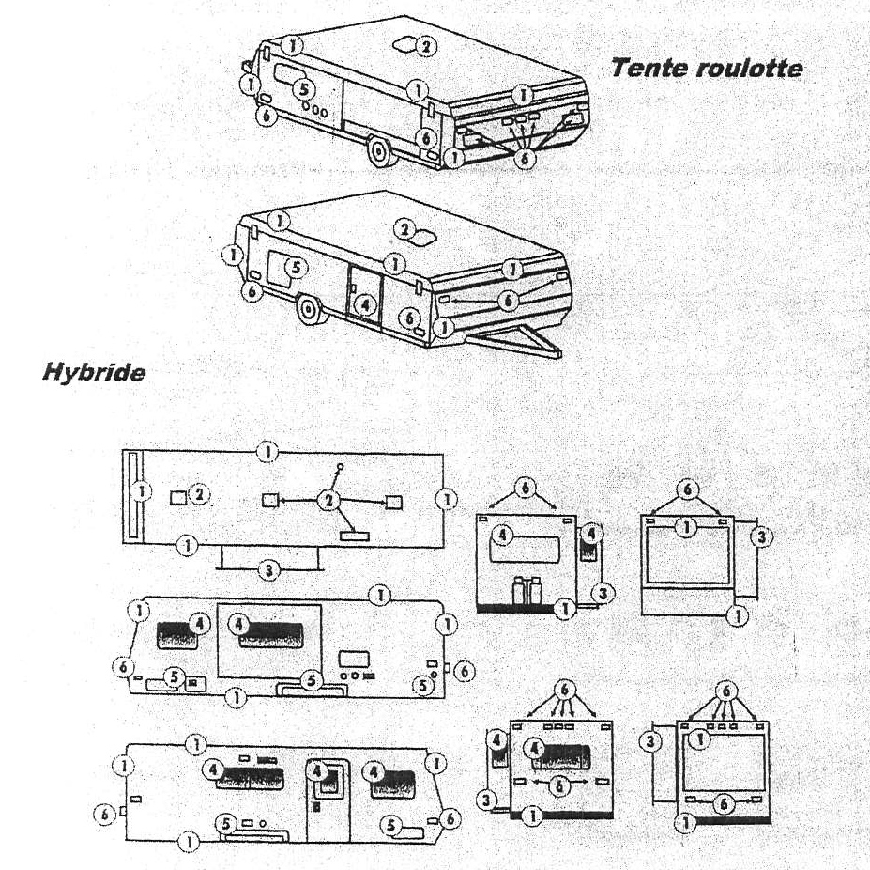

Set of siphon on pump
Summer mode Winter mode
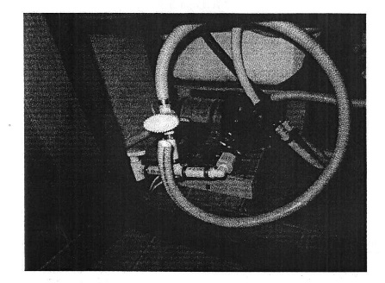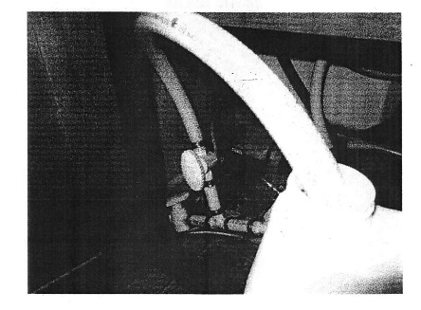

Hot water tank diverting assembly
Summer mode Winter mode
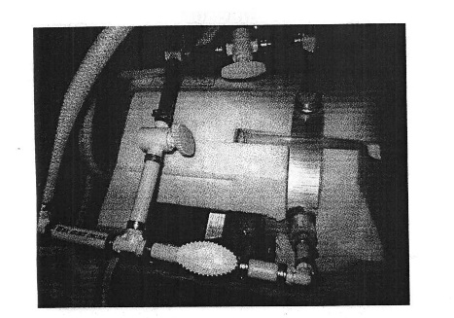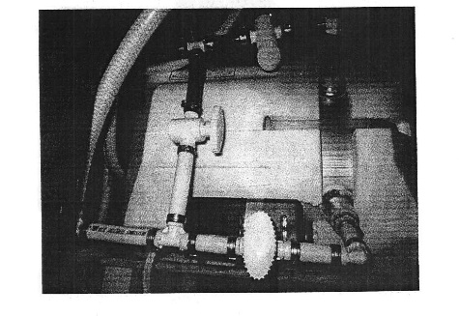

Checks to be done before winter closing
Contour sealer

Luggage compartments
Windows
Rock guard
Traffic lights
Furnace exhaust
Kitchen fan exhaust
Hot water tank
Refrigerator access door
Electrical input
Outdoor shower
City water inlet
Front door
Door retainer
Wheel fenders
Outdoor light
External cable socket
Water tank inlet
Corner molding

Roof sealer
Ventilation hatch 1
Ventilation hatch 2
Ventilation hatch 3
Ventilation hatch 4
Plumbing ventilation 1
Plumbing ventilation 2
Refrigerator ventilation
Radio antenna
TV antenna
Front seal
Rear seal
Skylight
Membrane condition
Roof extension 1
Roof extension 2
Seal

Fixation

Bottle cover
Emergency switch
Awning arms

Cleaning

Slab molding + gutters
General exterior (including roof)
Awning fabric

Roof sealer
Stabilizing cylinders
Luggage compartment lock
Extension rubber
Mechanical extension system
Door lock
Walking
Black and gray water valve
Window mechanism

Drainage

Fresh water tank
Hot water tank (cleaning)
Water pump
Kitchen tap
Kitchen water return
Bathroom faucet
Bathroom water return
Bath / shower faucet return
Bath / shower water return
Outdoor shower
Cleaning the valve filters
Toilet
Drainage + opening of the diversion system
Gray water tank

Recommendation

Storage of charged battery
Installation of air conditioning
Opening the refrigerator door
(detention stick)
Full of propane
Tire cover installation
Installation of dehumidifier pots
Antifreeze pumping
Cleaning of waste water tanks
Put on the ventilated cap and open the valves
black and gray water
Close the roof ventilation hatches
Check tire pressure
Clean the top of the extensions before closing them

Winterizing - Necessary

2 gallons of antifreeze
Pump siphon set
Pressure valve cap
Hot water diversion set
Wastewater rinse stick
Clear maintenance elbow
Ventilated black water cap
Hot water rinse tub
Lubricant for toilet seal
Treatment for extension rubber
Dehumidifier pot

Warning : If dishwasher / linen OR park model: 1 gal. additional antifreeze

Winterizing in 16 steps
Empty the reservoir of the outside water heater
Turn (Shoot) the valves of the whole detour (deviation) of the water heater
Empty the tank of fresh (cool) water by the valve under the vehicle and close her
Drain away and clean tanks of black and grey water (with the «fabric (tissue) digester» and a system of cleaning
To disconnect the intestine of food (supply) of water, to put the cork of valve of pressure, to open faucets and to put a compressor in a pressure enters 40 and 60psi then to close faucets
To install (Settle) if need be a set of siphon on the pump may put the tube in the gallon of antifreeze agent and put the pump in function (office)
In the continuation, one after the other one, to open every faucet ( hot then cold water) until the antifreeze agent pours(flows, sinks). As soon as the antifreeze agent pours (flows, sinks), to stop (arrest) at once the faucet.
Pull (Fire) the hunting of dress (toilet) until it pours pink (rose). Make the antifreeze agent rise in the shower head then disconnect its pipe of the faucet then her (it) put in the bath for winter. Do not also forget the outside shower in case you have one of it, the system of washerwoman / dryer as well as your refrigerator with a machine with ice cubes automatic (see the textbook(manual worker) of your refrigerator).
To Close the pump (1 ½ gallon of antifreeze agent should have passed).
The rest of the 2nd gallon must be put in equal part in the drains (p-trap) of the kitchen sinks and the bathroom as well as that of the bath.
Pay (Pour) half a bottle into the rest (bottom) of the dress (toilet) of the lubricant and the conditioner for the joint of dress (toilet).
Wipe (Suffer) the antifreeze agent in kitchen sinks, outline of the dress (toilet) (leave the bottom) and the bath because the antifreeze agent tries.
Open the valves of grey and black water and put the cork ventilated ready (in position) (a little water and antifreeze agent can pour (flow, sink), it is normal).
Put the cover of protection of the air-conditioned air, as well as those of the tires ready (in position).
Put jars dehumidifiers ready (in position), close blinds and trapdoors of ventilation (breakdown) in the ceiling.
Put plastics (plastic arts) in the doors of Access of the refrigerator and the water heater. Put some steel wool which does not rust in the escapes of furnace and to close with the ribbon the trapdoor of ventilator of cooking (kitchen).

RV opening in spring
Drain the antifreeze
Put clean water in the tank
Change the positioning of the siphon valve
Turn on water pump (see inside switch)
Open each tap (hot and cold water) until clean water flows
Check that the water heater drain cap is reset
Perform clean water tank treatment
Return water heater bypass valves to summer position
Replace water filter (indoor)
Start the system with city water or with the reservoir

Preparation of sewage tanks
Replace your ventilated cap at the drain exit with the regular cap
Check proper operation of exhaust valves
Clean the black water tank if you have not done so in the fall

Preparing the RV
Remove Protective Cover from Air Conditioner
Remove protective cover from tires
Remove steel wool from furnace exhaust
Remove plastic bag from water heater door
Open propane tanks, light in order: stove, furnace, furnace and finish with water heater
Check for propane leaks
Check smoke detectors, carbon monoxide and propane gas
Battery reinstallation in RV
Clean battery terminals and wiring
Vérifie Check electrolyte level (liquid) and add distilled water if necessary
Charge the deep discharge battery (2 AMP/h charger)
Install battery in RV and ensure correct connection of positive and negative wires

Maintenance of the sliding extensions (slide out) and stabilizers
Open the extension
Vaporize a fine layer of treatment on seals and let soak
Vaporize the dry lubricant on the gearing of opening, hinges, locks, ties, stabilizers (situated under the extension) and then close and open again the extension to grease well
Grease the worm and the base of stabilizers (jacks)

Maintenance of the roof (rubber membrane)
Visual and manual check of joints and membrane of the roof (if a joint is unstuck, to redo him with of sealing Dicor)
Remove the dust on the roof
Use a cleaner for rubber roof to wash him
Let dry completely then apply a treatment for rubber roof
Do not go back up on the roof before 48 am

Outside check
Check of the scellants of doors, windows and other accesses to the outer walls with the sealing
Do not forget that if to change you an access such as the entrance of drinking water, door of cable, etc., you will have to use of the ribbon butyle as well as of the sealing for the reinstallation
Replace the filter with water (outside)
Clean and make alterations of so necessary paint for the frame

Outside cleaning of the VR
Begin with the black tracks with a product specialized for black tracks
By means of a telescopic brush, wash the outside of the vehicle with a soap specially designed for VR
To facilitate the maintenance during the summer season, we advise strongly the wax use to polymers to facilitate the cleaning of the black tracks
The addition of extension lead of gutters (several types) turns out very advantageous given that the black tracks are mainly due to the dirt of the roof which flows on the sides of the vehicle and which causes them.

Maintenance of the paintings of tents-caravans
Clean paintings with a cleaner for canopy and fabric
In the case of tracks of mold, specific cleaners are available for this type of cleaning
Complete with the application of an agent of waterproofness
Use only products without chlorinating, of marks Magic Boss or others
Place 2 jars dehumidifiers in the tent-caravan for the season.

